York and Housing: Histories Behind the Headline project
November 2015
In November 2015 York and Housing: Histories Behind the Headlines was piloted. This document collates the different contributions made as part of the project. The methodology we were exploring – of inviting lots of different voices to open up and enrich understandings of the issues alongside developing collaborative histories using the city archives - underpins the My Future York project which was launched in March 2016. www.myfutureyork.org
Thanks to all you contributed and took part – we’ve pur this document together so your research and ideas can live on in the My Future York work.
Helen Graham, May 2016

Index of contributions
About the project
Why Housing?
November 11, 2015, City of York Council Leader Chris Steward and Deputy Leader Keith Aspden
‘Don’t wait for us to come to you, please come and talk to us’

November 12, 2015, Lizzie Nolan
‘York and Housing – First Archive Search!’

November 13, 2015, Phil Bixby
‘The real crisis York faces is a crisis of decision-making’

November 13, 2015, Alison Sinclair
‘From New Earswick to Tang Hall: How York set the agenda for social housing’

November 19, 2015, Carmen Byrne
‘Emotional Trauma, Community Upheaval, Long Silences’

20th November 2015, Darren Baxter and Alison Wallace
‘What is it that drives unaffordability in York?’

19th March 2016
Richard Bridge: A Right to the City? The new legislation driving gentrification

About the project
York is full of people who know an enormous amount about the city’s past. How can we pool and share all this local knowledge, research, memories and storytelling to help us understand the issues York faces today and inform decision-making about the city’s future?
In November 2015 the ‘York and Housing: Histories Behind the Headlines’ project will conduct an open inquiry into the histories of housing in York as a way of enriching public debate about the future of housing in the city.
We will do this by exploring the city archives, digitizing and sharing pictures of housing long gone, reading environmental health reports and looking at the city’s history of innovative social housing designs as well as through calling for personal photos and memories to explore how housing and making a home in York has changed over time.
We will also invite politicians, archaeologists and historians to offer their perspectives in order to help us understand how we’ve got where we are, including a guided walk by John Oxley, York’s City Archaeologist ‘Hearth and home: housing in medieval and modern York’ on 7th November, 2pm.
The project will conclude with two workshops – 20th (3-6pm) or 22nd November (1-4pm) – to explore what we’ve learnt and the implications for local decision making.
Why Housing?
York is one of the least affordable places to live in the UK and the least affordable in the north of England. Here average housing prices are over six times average wages and rent levels are unusual outside of the South East of exceeding a mean of £600 per month. The City of York Council has thousands on the waiting list for social housing.
In Autumn 2015 the Local Plan process will start again – following failure to pass the previous plan in 2014. Housing was a big issue in the local elections – and the new administration’s 12 point plan included a statement on the local plan, as reported by York Press:
Local Plan: The parties say they will prepare an ‘evidence-based Local Plan’ that would deliver much-needed housing, focusing on brownfield land and taking ‘all practical steps’ to protect the green belt and York’s character.
We’re planning to explore and extend what might count as ‘evidence’ and how collaboratively producing histories of housing in the city might help us debate, discuss, and even build a public consensus about, planning and development to inform the local plan as discussions start again this autumn.
The York and Housing: Histories Behind the Headlines project is a partnership between University of Leeds, York Explore Libraries and Archives and York Past and Present.

November 11, 2015
Council Leadership: ‘Don’t wait for us to come to you, please come and talk to us’
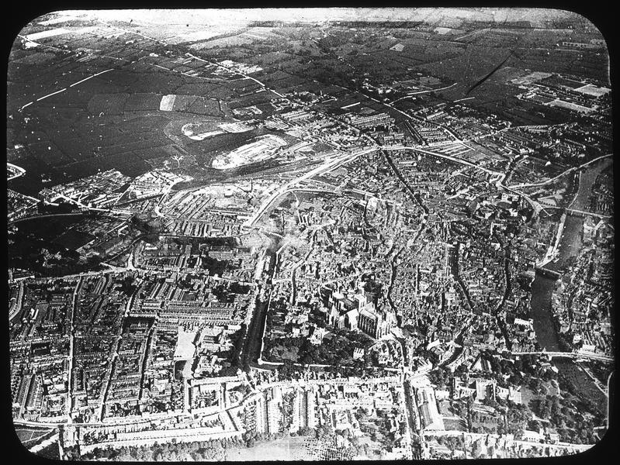
How do we plan the city’s future housing developments? Before Tang Hall was built. This aerial view of the city was probably taken in the 1900s. On the top left is Hull Road, just below is the road to Osbaldwick. Image: York Explore Libraries and Archives.

Introduction: City of York Council Leader Chris Steward and Deputy Leader Keith Aspden outline the importance of the Local Plan in ensuring the city shapes its own destiny, seeing it as a process that should bring ‘people together rather than driving them apart’.
Cllr Chris Steward and Cllr Keith Aspden
The Local Plan has been a controversial saga for York over recent years and at the heart of this controversy and often residents’ anger has been housing. Local Plans should ensure areas the right development and that residents have the facilities they need, whether houses, transport infrastructure or employment sites. In short, the Local Plan should be something that brings people together rather than driving them apart.
The need for a Local Plan is great, as it is not something we have had for years and if York does not manage it the government will intervene. As an administration we are committed to delivering such a plan, which will be viable, take residents with us and be supportable at inspection. There has been vast work to date on the Local Plan in terms of site suitability on issues like flooding, transport, protecting the likes of the green corridors into the city and the submission of sites for potential development. This work gives an excellent base.
We do however believe the level of housing proposed in previous drafts was too high and represents inappropriately high Greenbelt development, which is undesirable as it would both destroy the setting of York and also limit the regeneration of the city centre and suburbs; a greater prioritisation of brownfield sites will be of vital importance. In terms of the level of housing demand we have long argued the previous administration’s targets were too high and they have come down significantly to a level discussed at the last Local Plan Working Group of c. 800 homes per year, this downward revision will ensure we meet the demands of York rather than over-inflated growth targets.
We will work with local residents wherever possible, as they best know their areas and how they should evolve. Many rural areas are developing Neighbourhood Plans and these are a great such way of influencing development, pleasingly there also seems to be interest in such plans in urban areas. In urban areas in particular they can particularly influence the type of development, as there is by definition less available land.
As a bare minimum there will be the required legal six week consultation on the Local Plan a few months from now and which will set out the probable submission to the Planning Inspect, but there may be other more specific consultations. We have met with residents, businesses, Parish Councils and key bodies interested in our city. As an administration are keen to listen and engage wherever possible and so on the ‘how to feed in’ our point would be don’t wait for us to come to you, please come and talk to us – whether you just want to call or email or want us to attend your meeting we are hear to listen.

November 12, 2015
York and Housing – First Archive Search!
The York and Housing project is getting well underway, with our first peek at the archives on Tuesday 10th and the next session tomorrow, Friday 13th at the Local History Archives in York Central Library.
There is a huge amount of information in these archives – some of the boxes we’re looking at have not been opened since they were sealed decades ago, and following a coherent trail through misfiled boxes, maps and screwed up bits of paper is a real challenge!
The stories emerging are varied, with some of the volunteer researchers focusing on individual houses or streets and others on themes such as public health concerns or the movement of the people displaced by York’s previous housing plans.
Most of our explorations so far are in the Groves and Layerthorpe area, looking at the streets that the City cleared in the mid-twentieth century to make way for more modern housing or other development. Whole streets were bought by the Corporation by compulsory purchase orders, and we have a treasure trove of material relating to the process, from reports on the condition of the original housing (including photographs), to committee minutes, to the formal objections of those who weren’t so keen on the ‘compulsory’ part!
On Friday we will be looking further into the stories of these houses – including some streets that were never demolished and now comprise some of the most desirable properties in this already expensive city.
We are particularly interested in the areas around:
• Cleveland Place and Charlotte Street;
• Wood Street;
• Penley’s Grove Street, Garden Street and Lowther Street.
If anyone has any firsthand memories of these streets and the changes that occurred, or any stories told to you by others, we’d be very interested to hear them. Do you remember friends or relatives who were moved from the areas to be cleared? Where did they go? How did they feel about moving?
We know there are people out there with the real stories behind the archive material, and we want to talk to you. Perhaps you met your best friend growing up together on Lowther Street? Did you move to the same place after relocation? Did you keep in touch? Or perhaps this was your mother’s grocers shop, or your father’s barbers. How did it feel to leave the business they had built up over the years?
We’ll have more on this next week, along with other snippets from the past – there were how many illegal slaughterhouses? They did what in the music halls?! – and a full juicy dig into the records of the Inspector of Nuisances. See you then!
(This post written by Lizzie Nolan, Project Assistant)

November 13, 2015
Phil Bixby: The real crisis York faces is a crisis of decision-making

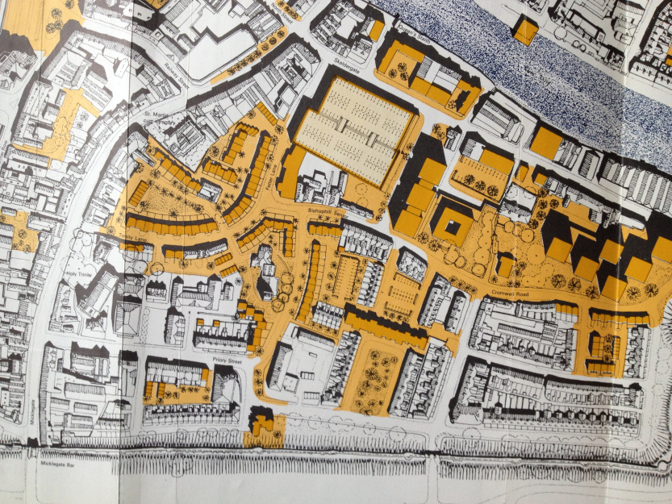
In yellow are new buildings proposed for Bishophill by the Esher Report, ‘York: A Study in Conservation’, 1968. Some of the proposed changes didn’t ultimately happen in large part due to community activism. Instead of the negative cycle of plans being offered for ‘consultation’ followed by anger, campaigns or disengagement, can we find a more creative way of planning the city’s future together

Introduction: One strand of the ‘York and Housing: Histories Behind the Headlines’ project is to seek articles, opinion pieces and interventions from people with something to say about the histories and future of housing in York. Alongside the archive work and events, we hope these pieces will inform, provoke and enrich public debate and create the conditions for engaged local decision-making.
Helen Graham talks with Phil Bixby, Chair of York Environment Forum and an architect with York-based Constructive Individuals which specializes in sustainable design and self- and community-led design and building.
Helen: In your view, what are the issues facing York and Housing?
Phil: We have this steamroller of increasing house prices and unaffordability in the city. Yet the real issue is that we don’t know how to decide. We don’t know how to move things forward and as a result we tend to fall into the ‘let’s try not to offend too many people’ scenario, which usually gives you the worst solutions. One of my issues with York is we are timid about what we do. We often lack the political will to push forward well thought through and bold solutions. We can’t stay the same. We’re not, we’re changing all the time. Do we want to be in control of change or be controlled by it? It is better to be in control.
Helen: Where does this timidity come from do you think?
Phil: The historical angle is that we are big village that has got really, really big. There is an attitude to politics which can be small-minded. The city council over the past few years has been more interested in infighting and back-biting and that has steered policy when we should be dealing with bigger issues. We bang on about how unique and special York is. And we’ve had lots of very interesting reports done such as the report Urbed’s A New Vision for York in 2003 and the 2010 York New City Beautiful report. Both reports were full of all sorts of interesting possibilities, all spelt out in glorious Technicolor, but nothing has happen. It’s time we upped our game. We desperately need politicians and officers in the Council to stick their necks out, take some flak [I feel for Dave Merritt, he did stuff which was unpopular and has been crucified for it.]
York is changing. If you say ‘it’s fine as it is’ then York is slightly different even as you are saying so. Development in York has happened in a piecemeal way, drip, drip, drip. You get the filling in of urban green space, suburbs, but you don’t get the bigger decision. You don’t get place making where you actively create urban or suburban centres or spaces, buildings and infrastructures that enables communities to happen. The danger is you just get dormitories which lack facilities and have no character.
Helen: What did you think about the last version of the local plan which failed to be passed in November 2014?
Phil: It was fairly shambolic. The density proposals were very low. It sidestepped the green belt issues. It was about avoiding getting shot, rather than doing something good. Specifically the low density on York Central and the British Sugar site needs to be looked at again.
There are a few developments that have happened which have been good. I’m thinking of Derwenthorpe, where there was a real effort to crank up densities. They didn’t just say let’s have some green space where we might allow ball games, what they did was let’s look at the urban realm so that spaces could be more used, places for kids to play, traffic to move and views to look out at. Talking to the developers, the property valuation was still the same but the houses sold more quickly. Buyers could see it was going to be a good place to be.
Derwenthorpe is what becomes possible when we have Joseph Rowntree Housing Trust holding the reins and setting the brief. The city needs to become the JRF in these developments.
Helen: York has seen development happening over the centuries, are there things in the city’s traditions that we can build on in addressing housing need today?
Phil: York is always seen as being distinctive because of the compact medieval centre. It historic core is often pictured a little bit like a floating yolk in a large fried egg of utterly characterless suburbia. But there have been really inspiring visions. For example Urbed’s Nicholas Falk and David Rudlin developed a fascinating idea for new Garden Cities in 2014. In this plan – which could be for any historic town of around 200,000 people but was based on York – used a snowflake approach to build on three bits of the green belt but also develop the quality of green spaces both around exiting city boundary and the new developments (not just ecologically impoverished farmland but woods and wildlife). It was a really radical proposal and had so much more substance than anything else that had been described so far.
Helen: So there are lots of fantastic ideas but it feels like we have some systemic issues in York in terms of decision-making. For example we have pretty flawed consultation processes – when we were doing the ‘How should heritage decisions be made?’ project in York, and having lots of public conversations about decision making in the city, the metaphor of a ‘fig leaf’ was constantly being used to describe consultation.
Phil: Community consultation in York, and in most places, has a really bad history. What tends to happen is that decisions are made in smoke filled rooms, then consultation happens. The underlying feeling is that the agenda is already set, and it is set, because the public only get asked certain questions. With the ABB site redevelopment, the Council did jump on board with community engagement and took a reasonable crack at it. There was a community advisory group and interesting things came out but it was still after pretty much everything had been decided. It was put out there when the masterplanning was about the detail rather than fundamentals. At that point all people can offer is ‘oh that’s not too bad’ or ‘I don’t like it’. You need to involve people at the right time and ask them the right questions. We need to start taking the conversation back to the point when creativity can happen.
Helen: Absolutely, the ‘fig leaf’ approach leads to negativity and anger because people know they can’t meaningfully contribute and is actually really damaging to local democracy. How might we start to build creative conversations about the future of York?
Phil: I think we should really work at creating an environment that enables ideas to be kicked around. When I first start working on community based stuff I used Planning for Real. A key idea in Planning for Real is separating ideas from people. One of the dangers with the consultation approach is that by the time communities get to hear about plans they are completely attached a specific developer or administration. This then tends to generates local opposition, often personality-based. We need to find ways of defusing that by starting conversations much earlier and start moving towards positive stuff.
Design – whether of houses or cities – should be possible and it should be fun. Design should be hugely enjoyable. The process of creativity should make everyone involved glow with well being and if you are having public meetings where everyone goes away annoyed then you’re doing something wrong.

November 13, 2015

Alison Sinclair: From New Earswick to Tang Hall: How York set the agenda for social housing

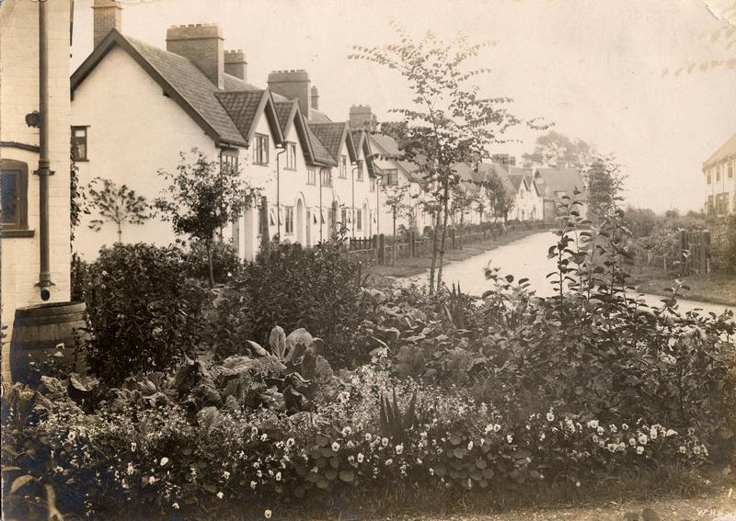
Poplar Grove in New Earswick. New Earswick became influential l in the development of national social housing policy in the early twentieth century. Credit: York Explore Libraries and Archives.

Introduction: York Historian Alison Sinclair shows that the ambitious designs for new housing developed by Joseph Rowtree in New Earswick in the 1900s influenced not only the development of Tang Hall twenty years later but also set a template for social housing nationwide under the Homes fit for Heroes scheme.

In 1901 land was bought at New Earswick by Joseph Rowntree for the construction of an experimental village of ‘improved houses’ for working people in York. In 1902, he engaged the partnership of Barry Parker and Raymond Unwin as the architects for his experimental village. In the same year, the first tentative plan for the village was drawn up by Parker and Unwin, and between 1902 and 1907 the first houses were designed and constructed in Western Avenue, Station Avenue and Poplar Grove.

In various lectures and publications, Parker and Unwin set out the basis of their ideas for New Earswick. Most were applications of the principles of a book entitled Tomorrow: a Peaceful Path to Real Reform published in 1898, and containing proposals for the alleviation of the appalling housing conditions of working people of the time. The book led to the founding of the Garden Cities Association, the first conference of which was held in 1901. Here it seems Joseph Rowntree’s son, Seebohm, met the two men who were to become the architects of his father’s visionary plan for a new village.

From Garden Cities ideas came features at New Earswick which became influential in the development of national social housing policy in the early twentieth century. The layout of the new village would use existing natural features on the site, and houses would be set in gardens along streets edged with grass verges. Blocks of houses would be built in short terraces of four or sometimes more, giving the opportunity to make an architectural composition. New streets would be far from the long unbroken terraces of uniform houses commonly provided for Victorian working people.

It was a fundamental belief of the architects that their responsibility did not end with the walls and roof of a house but extended to the internal arrangements as well. The internal plans of their houses were designed to change the standard arrangement of rooms in a typical Victorian terrace house, with an under-used parlour at the front, the living-room behind, and an extension at the back containing the scullery, and earth closet and coalhouse accessed from outside.

In consultation with the first tenants at New Earswick, the two architects developed three types of room layout for their house plans. Houses had no back extensions and all the services were accommodated under the main roof. The most basic was the ‘through living room’ plan in which there was one large ground floor room stretching from back to front of the house, lit from back and front, in which all the daytime activities were carried out. In the second type the ground floor was divided into two rooms, one the living room, the other the scullery. The third type was not at first proposed by the architects until the first residents in the village requested it, and that was a house with a separate parlour which could be used for ‘best’. In their innovative plans, domestic services were accommodated beneath the main house roof and no longer in a back extension; all houses were provided with two or more separate bedrooms, a kitchen range designed to provide hot water for both kitchen sink and bath, and an inside lavatory. Room arrangements were made inter-changeable so that house layouts could be orientated to make the most of fresh air, natural light and “cheerful outlook”.

With the start of the First World War, building at New Earswick came to a halt and Raymond Unwin was appointed Chief Town Planning Inspector to the national Local Government Board. In this role, he brought the principles behind New Earswick to early twentieth century national planning policy. Crucially the three house plan types developed at New Earswick were included in a government Manual produced in 1918 to accompany national legislation leading to the ‘Homes fit for Heroes’ campaign. Under this initiative, government funds were made available to local authorities for building good quality homes for returning war heroes and their families. The Local Government Board Manual on the Preparation of State-aided Housing Schemes was produced in 1919. It advised that “… houses should be designed to provide the sunniest aspect to the living-room and the majority of the bedrooms”, and each house should ordinarily include a living-room, scullery, larder, fuel store, lavatory, a bath in a separate chamber, and three bedrooms. Model plans illustrated included a half living-room house, a through living-room house, and a parlour house.

In 1919, York Corporation responded to the ’Homes fit for Heroes’ campaign by setting up a Housing Committee whose first action was to purchase land at Tang Hall. The following year, contracts were let for the construction of 185 houses. These were for a number of through-living-room house plan types, some with 3, some with 4 bedrooms; and many for the parlour plan type, similarly with 3 or 4 bedrooms. In this initial phase of social house building in Tang Hall it appears that no half-living-room plans were provided, although they were introduced on the estate subsequently. Nor were different house plans specially orientated to take advantage of natural light and outlook. By the end of February 1921 the first houses in Carter Avenue were completed, and work was in hand in 4th and 8th Avenues.

By 1928, more than a thousand new houses had been completed in Tang Hall. A few years ago, two older ladies of my acquaintance told me how, as children living in poor housing in Walmgate, they had run down Hull Road to look at the beautiful new houses they were going to move into with their families. From these early beginnings, York Council continued to build social housing right across the City, until legislation in the 1980s altered the statutory duty of local authorities to provide low cost housing.

November 19, 2015

Carmen Byrne: Emotional Trauma, Community Upheaval, Long Silences

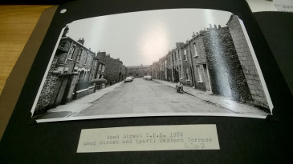

Introduction: In the first of our case studies produced by researchers working with the York Explore archives, Carmen Byrne focuses on Wood Street, a street of 1850s terraces demolished in the 1970s to make way for new social housing. Drawing on Health Inspection reports and records associated with Compulsory Purchase, Carmen reveals the opposition to the Council’s decision to demolish from the York Group for the Promotion of Planning and evokes the serious emotional impact of living in a house slated for demolition.

Having lived in a terrace house built in the mid19th century, albeit in the depths of Lancashire mill country, I was drawn to Wood Street, located at the heart of York, because of its familiarity. Built in the 1850’s the terraces on Wood Street were earmarked for compulsory demolition at the beginning of the 1970’s with housing inspection reports declaring them unfit for human habitation. Rising damp, uneven and worn floors, steep badly lit staircases and poor ventilation were regular features of the 1971 House Inspections: all sounding very similar to the little terrace I lived in only 5 years ago, where despite re plastering, insulating and some structural work, the damp appeared to be as much a part of the building as the brickwork. Despite waging a never ending battle with the damp, this terrace was home for 10 years, so I can very much sympathise with the residents of Wood Street when they were informed their homes were at threat. It’s easy for us to look back from the warmth of our centrally heated houses and be slightly mortified at the lack of heating, warm water and bathrooms in some of the Wood Street properties, but it’s worth remembering that this was still pretty commonplace at this time. Although probably less common, was the bath tub fitted into the kitchen of 22 Wood Street: unfortunately there’s no photographs in the archives- just a slightly bemused note from the housing inspector!

With 43 houses and 59 occupants reported in 1972 as part of the compulsory purchase order, it was necessary for the Council to both purchase homes from owner/occupiers, as well as from private landlords (some of properties were vacant), as well as relocate tenants from social housing. It appears as though some of owner/ occupiers were also relocated with those tenants from social housing and private landlords. In all, there were a lot of people to keep informed, negotiate with and support with alternative arrangements as part of the street clearances.

The whole process from housing inspections in 1971 to the last relocation apparently in 1976 took 5 years. We can imagine the turmoil of residents especially when there appears to have been an element of distrust around the motives for demolition, rather than undertaking a refurbishment. The York Group for the Promotion of Planning voiced their concerns around the cost of a demolition project, when social housing was already at a shortage, with over 1300 on the waiting list and with “houses being allowed to decay and fall into disuse” (26th February 1974). Being “allowed” to fall into decay suggests a lack of care over a long period of time and as the York Group for the Promotion of Planning stated this lack of care for small terraces was habitual across York, the condition of housing on Wood Street appears typical. There are a few ways to think about this: perhaps it was a reflection of a lack of refinement in managing social housing; perhaps firmer legislation was required to enforce private landlords to take better care of their properties; or maybe it was due to a longstanding social housing agenda to reshape York. Proof of Evidence for the Compulsory Purchase was given as “All the houses show rising and penetrating dampness in varying degrees, due to the inherent defects of the construction” which suggests no matter the care given to the properties, the fundamental issue is the construction itself which could explain the widespread state of small terraces across the city. Whatever the motivations, the process from inspection to relocation would have left property owners (the council included) in limbo, in that property maintenance would have possibly been perceived as a waste of money- triggering a downhill spiral over 5 years for properties which really needed care and attention much earlier.

The emotional trauma of the residents of Wood Street and nearby Eastern Parade, who were also living in the same housing limbo for a number of years, can be seen in the archives through the letters written to the Housing Inspector. One tenant from Eastern Parade wrote to the Public Health Inspector in January 1973 requesting further information as she’d “held back a week’s holiday which must be taken before the end of the financial year”, so she was “naturally anxious to know if we are likely to move in the near future”. The resident’s uncertainty stemmed from having no news since she visited the Inspector’s office around one year earlier and her concern about a series of “cleaning and replacement jobs which must be done if we are going to be here longer”. This would suggest that there was little transparency or communication with the residents during the process, and again reinforces the lack of ongoing investment into properties already resigned to demolition. It must have been frustrating, and in some cases very upsetting for residents: records of visit by a member of the council to a recently widowed owner/ occupier outlined “…it is hearsay, but acceptable, that his mental and physical condition was affected by four years of anxiety” in reference to the death of her husband.

Over 60 residents from the local area registered complaints for the demolition, and wider support came from the Yorkshire Evening Press. The local media reported that although some houses are unfit “especially after being empty for long periods of time” this doesn’t apply to all of them “The majority are structurally sound and have gardens which are large by present day housing standards” (Jan 9th 1974 Yorkshire Evening Press). So, we begin to see a discrepancy between the framing of Wood Street on the Compulsory Purchase Order as being all unfit for human habitation and the perceptions of the general public (residents included). Examination of the compensations paid to the different property owners of Wood Street seems to reinforce the public and resident perception that not all houses on Wood Street were inhabitable. At a time when the average UK house price was £5,632 (not York or property specific) the highest compensation payment of £3500 is 62% of the market value compared to the lowest payment detailed in the archives of £175 at 3% of the average property value. This is a marked distinction which suggests varied house conditions. Owner/ occupiers also seemed to have looked after their homes more than private landlords renting them out, as the average owner/ occupier compensation was over £2,000.

Broadly speaking there were a great deal of concerns about the loss of a community which had been established for over 100 years and indeed memories of Wood Street describe a thriving community. A member of the York Past and Present Society recalls how she “to play in the street as a kid in the 1960’s… there were three stables, Horwells’ coal, Rhodes fruit and veg, Leo Burrows Fruit and Veg…an old Cobblers shop and a mechanic had his workshop there too”. There was a mix of residents, from families to OAPs and we can also see a range of occupations from students to Rowntree process workers, bus drivers, security officers and home helps. The green eyed monster can definitely rear its head when we think about how our communities today are often less defined by the streets we live in and more by our digital connections. Another reason for a nostalgic view of Wood Street in 1971 is the amount of rent paid in proportion to the average wage. Of the residents of Wood Street with listed occupations the average rent was £1.44 per week or £66.12 per year. In 1971 the average UK salary was £41.67 per week or £2000 per year which means a remarkable 3% of income would have gone towards rent. Putting this into a modern context of an average York wage £22,000 (in 2013) and with a small house (similar proportions to a mid-century terrace) renting in York for around £700 per month, rent can easily now be a massive 38% of our income!

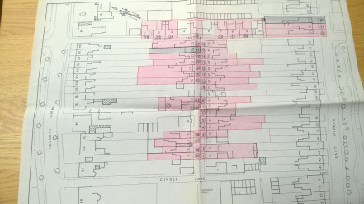

The Wood Street community was gradually dispersed between 12th February 1975 and 19th August 1976 based on the relocation dates found in the archives (there may be more tucked away). The owner/ occupier of 23 Wood Street had purchased the property in 1931 and was relocated to Hewley Avenue on 7th April 1976: moved 1.1 miles from a property which had been home, and residents which had been neighbours for 45 years. On average new homes seem to have been found within a 1 mile-ish radius of Wood Street, but in many cases the residents were located opposite directions- in essence 2 miles or so from their longstanding neighbours. A time of upheaval both for those leaving their community but also for those who were left behind in an emptying street. The Yorkshire Evening Post ran an article highlighting the trauma face by the 75 year old resident of 32 Wood Street living between two empty properties “My life’s a misery. They (“tramps”) climb over my wall, walk up the garden and have thrown bricks. I am very frightened” (6th January 1973). Although prior to the beginning of the relocation dates, the issues of empty properties and fragmented communities must have impacted on the happiness of those remaining, especially as more and more people moved.

In the early 1980’s new social housing was built on Wood Street, including flats. Today these still stand and appear to remain largely social housing, with only 2 recent property sales. A far cry from the 1970’s rent of £1.44 per week, a flat on Wood Street sold in 2003 for £82,500 with an estimated value of £147,000 in 2015. How times change.

November 20, 2015

Darren Baxter and Alison Wallace: What is it that drives unaffordability in York?

York’s historic charm, its good transport links, the expansion of its educational institutions and the relocation of big businesses all contribute to its allure as a place to live. The frequent reports citing the city as one of least affordable places to live in the country are therefore no surprise to York’s 200,000 or so residents. Darren Baxter and Alison Wallace for the University of York’s Centre for Housing Policy identify the key factors driving unaffordability of housing, suggesting that strong civic leadership is needed to prevent the people who do the very jobs that sustain the economic life of the city being pushed out.

Supply

The exact number of new homes that York needs is unclear and has been subject to some considerable debate. Evidence underpinning the local plan prepared by the City of York council suggests that 850 homes need to be built per year to take account of predicted population growth over the next 25 years on top of the need to address the current backlog of affordable housing. What is clear however is that housing delivery so far has failed to come anywhere close to meeting these proposed, and subsequently withdrawn, targets.
Supply is also not just a question of delivering number of houses. As is the case at the national level, it is necessary to ensure that homes are built in the right places, of the right tenure mix and for the right price. This is particularly pertinent given that research conducted by campaigning charity Shelter has estimated that as little as 1% of homes with 2 or more bedrooms in the city are affordable for couples with children on average incomes. The supply of affordable housing is also likely to worsened given current policies surrounding social housing.

NIMBYism

Plans to plug this shortage have historically been hugely contested as demonstrated in opposition to the council’s now withdrawn local plan. Such hostility has been a frequent feature of local politics, particularly in the villages surrounding the city where residents and local politicians have objected to building on the green belt, new sites for travellers, and the loosely defined notion that development will change the character of the city. Therefore that which makes York an attractive place to live is also that which is used to mount opposition to building the homes needed to meet an increasing population.
Income

In understanding the issues in York it is also important to recognise that the cost of housing is only one aspect of unaffordability. Whilst property and rental prices in York are higher than in much of the rest of Yorkshire this is not necessarily matched by pay. The city has been fortunate to have maintained high rates of employment but median earnings for jobs in the city are comparable with than the regional average. So whilst York may have a property market more in common with southern regions its labour market does not necessarily compete.

For those on particularly low incomes the problem is greater. The full impact that housing benefit has in acting as a buffer against poverty, as found by colleagues at the Centre for Housing Policy in work conducted for Joseph Rowntree Foundation, is limited given the way in which local housing allowance is calculated. York’s recently retired MP Hugh Bayley observed on multiple occasions that LHA rates are calculated with respect to rental sub-markets, which include the much more affordable Tadcaster, Selby, Malton and Barlby, average rents are deemed to be lower than they are in reality resulting in low rates of being paid to low income tenants.

The way forward?

Municipalities in other European countries have greater powers to acquire land and direct development compared to local authorities in the UK, but we need strong civic leadership to deliver the new homes and infrastructure we need to support them. Other areas like Cambridge have recognised that economic growth is tied to the provision of new homes and have worked across local authorities to plan how those homes, roads, transport, schools etc. will be delivered. Often providing transport and schools first so existing residents are not adversely affected. We also need a range of housing providers to build quality places–including housing associations, small firms and self-builders- and cannot rely solely on the large housebuilders. Other local authorities across the country are taking the lead and acting as developers themselves to ensure that homes are actually built out of the type required.

Failure to grasp that York needs more homes will lead lower-income and younger people out of the city changing its character and raising questions around urban justice. What’s more this may make the city a less attractive place for those whose jobs are essential to industries, such as tourism, which contribute to the economic life of the city but which are paid at a level which may make accessing housing a challenge.

19th March 2016
Richard Bridge: A Right to the City? The new legislation driving gentrification
Introduction: In November the York and Housing: Histories Behind the Headline project invited different people to outline their views on the issues facing housing in York. In March the project began again – through a stall in Parliament Street on Good Friday – with a focus on crucial issues for the Local Plan, not only housing but also public space, flooding, traffic and green space. Many ideas and issues were raised through discussions on the stall but housing came up again and again. Richard Bridge discuss how York’s housing situation will be affected by recent and proposed legislative changes – how can York resists the drivers which look likely to price out many of the people who have built their lives here?
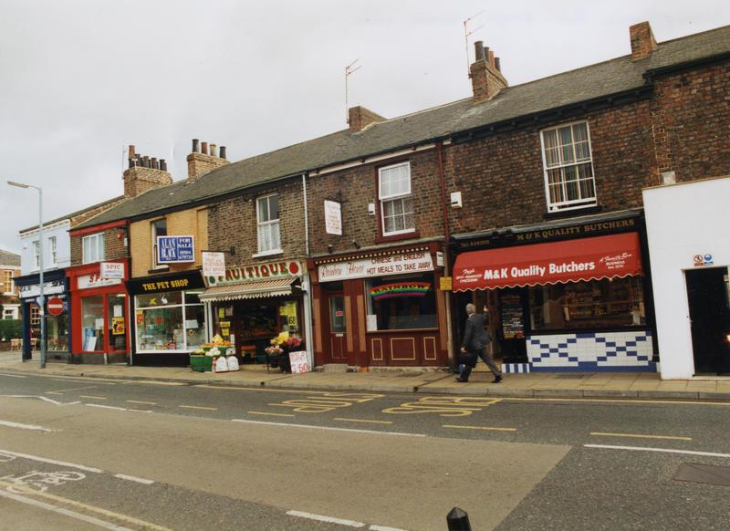York should celebrate Bishopthorpe Road’s recent victory as Great British High Street of the Year but, Richard Bridge argues, there are inherent risks to that success which also apply to other areas of York.
Richard Bridge
York’s Histories Behind the Headlines throws a fascinating spotlight on York’s rich and textured housing past and asks how that may or should influence and shape its imagined future. Whilst I’m no historian, it is clear that York in recent times has provided a mix of owner-occupied, private and social housing for its residents. Joseph Rowntree Foundation provide robust research that suggests a healthy mix of tenure types – providing for different age groups, ethnicities, household types and differing income levels – makes for a more cohesive society.
However, the implementation of recent and future housing and welfare reforms places that under serious jeopardy with York’s current and future housing crisis being potentially a microcosm of London whereby the housing landscape is dominated by more affluent households with poorer families displaced out of the city or at best, concentrated into small pockets of social housing reserved only for its poorest residents.
Back in the 80s, I lived on Northcote Road in Battersea, London which rapidly metamorphosised from a working-class street with a daily street market to what is now known as ‘Nappy Valley’ with a mix of boutiques, chains and cafes catering for its young, affluent and productive demographic. Gentrification – wherever it takes place – tends to render local inequalities near-invisible. It would be disingenuous of me though not to admit to enjoying some of the fruits of what we often call ‘regeneration’. Indeed, there is an argument that it creates more jobs, less crime, improved services and so forth. Nevertheless, whilst for instance Bishy Road has been the host of some great street parties providing a vibrant community ethos and recently won GB High Street of the Year (and in Stanley and Ramona serves perhaps the best coffee in York!), its success hides an inherent weakness. Its popularity leads to rising residential and commercial rents, and rising house prices, meaning the area provides for a more affluent clientele, and potentially pushes out less profitable businesses. Bishopthorpe Road is certainly not unique to those dangers in York or elsewhere and currently still provides a good mix of affordable shops. But there are risks.
So what are the imminent dangers to York? Focussing on the rental sector, costs have become increasingly less affordable in recent years and due to the Housing and Planning Bill and the Welfare and Work Bill, the position is likely to worsen significantly, particularly for York’s poorest residents.
Affordability of private rents now
In-work poverty has steadily become more prevalent due to low wages with over two-thirds of Housing Benefit claimants now having someone in work.
Table 1: Housing benefit entitlement in York
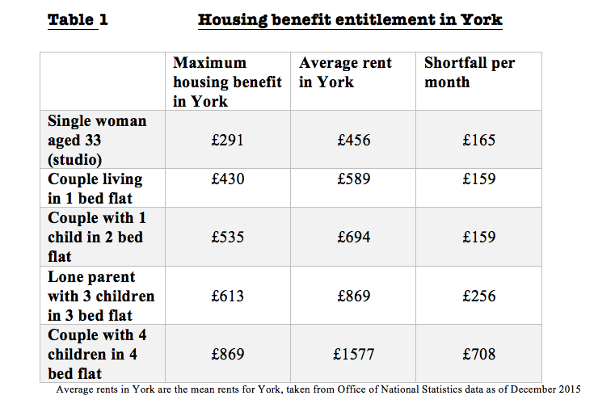
Private renters in York are already significantly disadvantaged as the level of Housing Benefit is based on a Broad Rental Market Area which means the eligible benefit is set at the level of outlying towns such as Selby, Tadcaster, Easingwold and Malton which creates significant monthly shortfalls for lower wage households (see Table 1).
In essence, this means rents for people not in paid work – carers, disabled people, unemployed – or low paid work are unaffordable and only made worse by York’s regressive council tax support scheme. So how do people make up the shortfalls in rent? Perhaps by borrowing from friends, or cutting back on food and heating. Some may get into debt whether accruing rent arrears, risking eviction or borrowing from high cost lenders. Others perhaps move out and sofa-surf. Ultimately, the shortfalls are unsustainable.
For social tenants, the ‘bedroom tax’ has caused similar hardship. Back in 2013, I recall speaking to a disabled woman in Foxwood who explained she could not manage the shortfall and would have to move away from York. Reduced to tears, she explained that she had lived in Foxwood all her life and this was where her life was and had always been – her family, her grandchildren, her friends, her community.
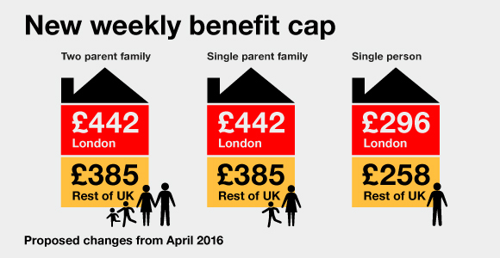Credit: Shelter*
But worse is on the horizon. Many will have heard of the benefit cap. Hugely popular and premised on ‘fairness’ to the taxpayer, few families in York have thus far been affected. This year however, the cap reduces to £20,000 meaning that for the families already affected, there will be a further immediate drop in their income of £115 per week. Moreover, the cap will now capture a much larger swathe of families in York (see Table 2 for an illustration of how families may be affected.
Table 2 Projected shortfalls for households in York upon implementation of benefit cap
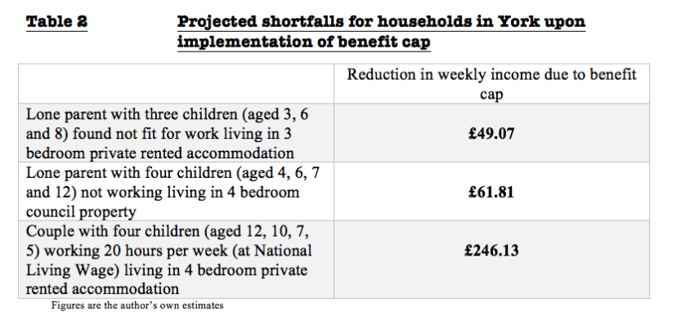
Interestingly, if the family in the council property illustrated above have to move out as they can no longer afford the rent, it is unlikely that the property will be offered to one of the many other families waiting on the council housing list. Instead, under new Government rules, City of York council will have to sell its higher value social housing in order to finance the Government’s Right to Buy proposals for Housing Association tenants. When sold, these larger council properties are likely to be sold to private investors and let to students.
So, of course, the answer is to find enough work which will exempt you from the Benefit Cap. Apart from the simplistic notion that people are always able to work, or that work is always available, we now encounter a further problem. Under the bizarre ‘Pay to Stay’ rules being introduced in April 2017, many households renting from the council earning in excess of £30,000 will be expected to pay a market rent for their council rent. So for the family in a 4 bedroom Housing Association property, their rent would be likely to increase by more than £1000 per month!! For a couple, a joint income of £30,000 is hardly a high income – in reality, it equates to two full time wages at the new national living wage. We always hear about ‘doing the right thing’ – surely two people working full-time could not fit the government rhetoric better and yet, the Government proposes to hit those families in York with a £250 per week work penalty.
More to the point, many families who have been brought up in York will be and are being faced with difficult decisions. Some of the poorest – and even more well-off – are simply priced out by the cost of private rented housing – simultaneously, the Tories have sounded the death knell of social housing in York under the pretence that families can aspire to buy in the city. And for larger families in particular, the Benefit Cap signals their displacement out of the city despite the severe social injuries that may cause young and old alike. And for those in social housing that ‘do the right thing’, difficult choices remain as to whether to pay massive rent hikes in properties that they have invested their lives in, to reduce their income (so they fall below the threshold) or again be displaced to different locales.
I admit this paints a particularly gloomy picture of ‘affordable housing’ in York which provokes the question David Harvey – a well known urban geographer – recently asked, ‘who has the right to the city?’ Is it implicitly reserved for the moneyed capitalist classes or more positively, can all of York’s residents claim some kind of democratic power to remake the city through radical, innovative and different forms of housing?
*The Author would like to thank Shelter for the use of this infographic. This blog is not endorsed by Shelter.

